WEEK-2:Mockito Exercises HandsOn

Exercise 1: Mocking and Stubbing

public interface ExternalApi {
String getData();
}
public class MyService {
private ExternalApi api;
public MyService(ExternalApi api) {
this.api = api;
}
public String fetchData() {
return api.getData();
}
}

import static org.mockito.Mockito.*;
import static org.junit.jupiter.api.Assertions.*;
import org.junit.jupiter.api.Test;
import org.mockito.Mockito;
public class MyServiceTest {
@Test
public void testExternalApi() {
ExternalApi mockApi = Mockito.mock(ExternalApi.class);
when(mockApi.getData()).thenReturn("Mock Data");
MyService service = new MyService(mockApi);
String result = service.fetchData();
assertEquals("Mock Data", result);
}
}
In pom.xlm file:
<!-- JUnit 5 -->
<dependency>
<groupId>org.junit.jupiter</groupId>
<artifactId>junit-jupiter</artifactId>
<version>5.9.3</version>
<scope>test</scope>
</dependency>

<!-- Mockito -->
<dependency>
<groupId>org.mockito</groupId>
<artifactId>mockito-core</artifactId>
<version>5.11.0</version>
<scope>test</scope>
</dependency>
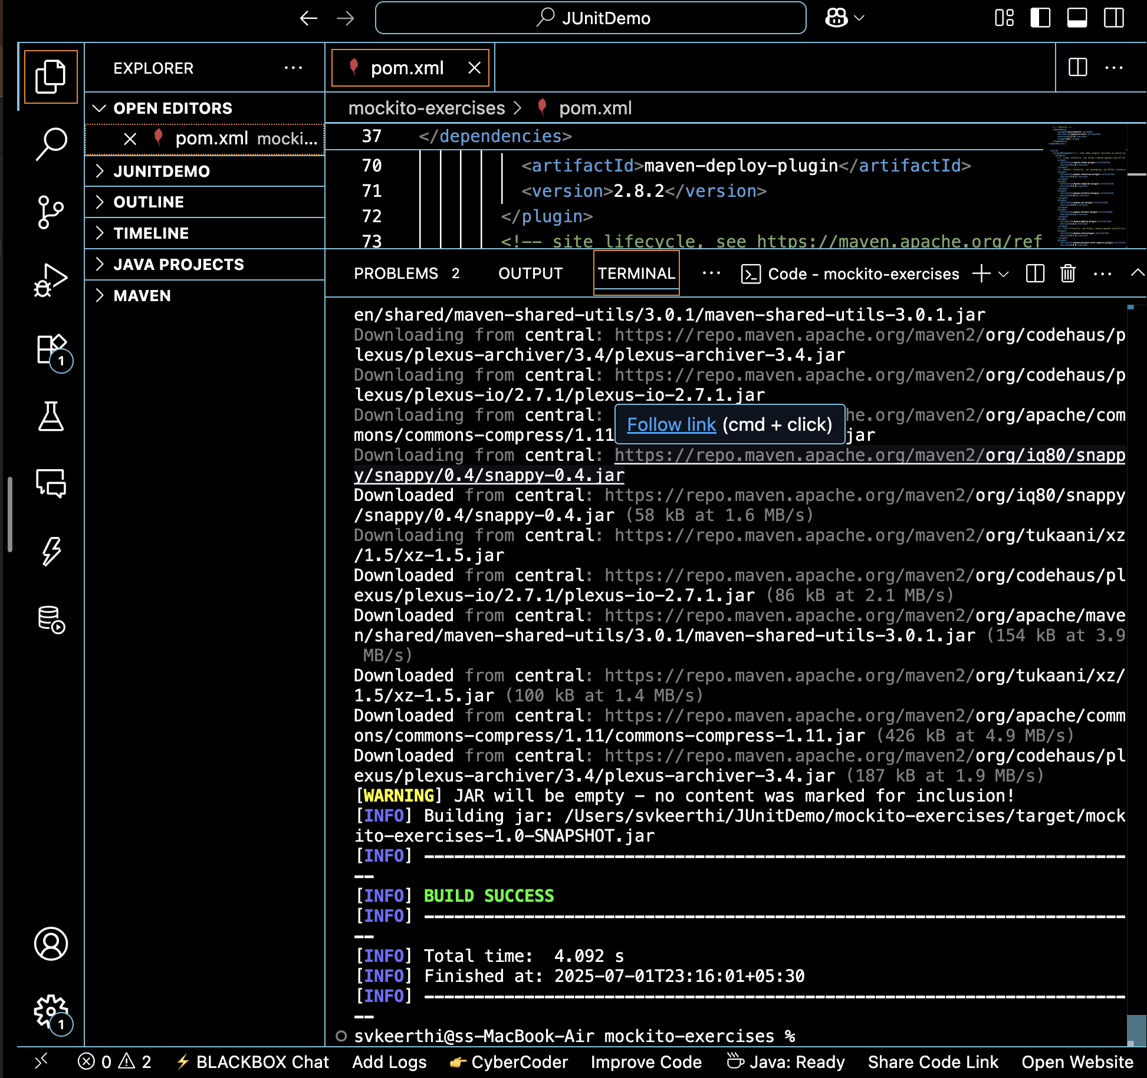
Output:

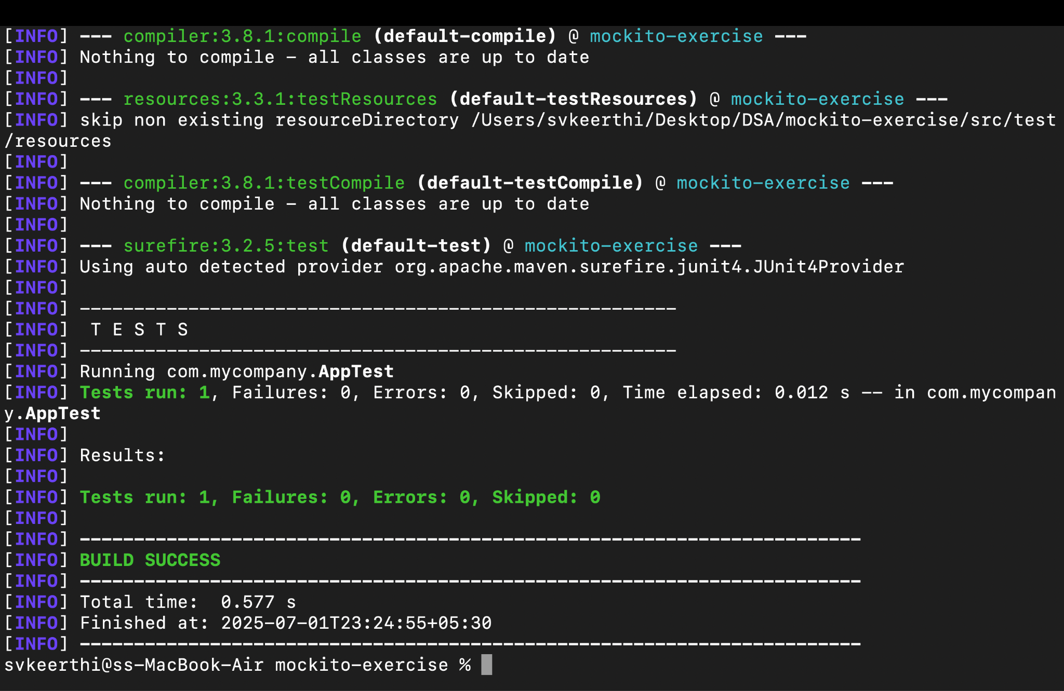

Exercise 2:Verifying Interactions

MyServiceInteractionTest.java
package com.mycompany;
import static org.mockito.Mockito.*;
import org.junit.jupiter.api.Test;

public class MyServiceInteractionTest {
@Test
public void testVerifyInteraction() {
ExternalApi mockApi = mock(ExternalApi.class);
MyService service = new MyService(mockApi);
service.fetchData();
verify(mockApi).getData();
}
}

AppTest.java
package com.mycompany;
import org.junit.jupiter.api.Test;
import static org.junit.jupiter.api.Assertions.*;
public class AppTest {
@Test
public void shouldAnswerWithTrue() {
assertTrue(true);
}
}

MyServiceTest.java
package com.mycompany;

import static org.mockito.Mockito.*;
import static org.junit.jupiter.api.Assertions.*;

import org.junit.jupiter.api.Test;
public class MyServiceTest {
@Test
public void testExternalApi() {
ExternalApi mockApi = mock(ExternalApi.class);
when(mockApi.getData()).thenReturn("Mock Data");
MyService service = new MyService(mockApi);
String result = service.fetchData();
assertEquals("Mock Data", result);
}
}

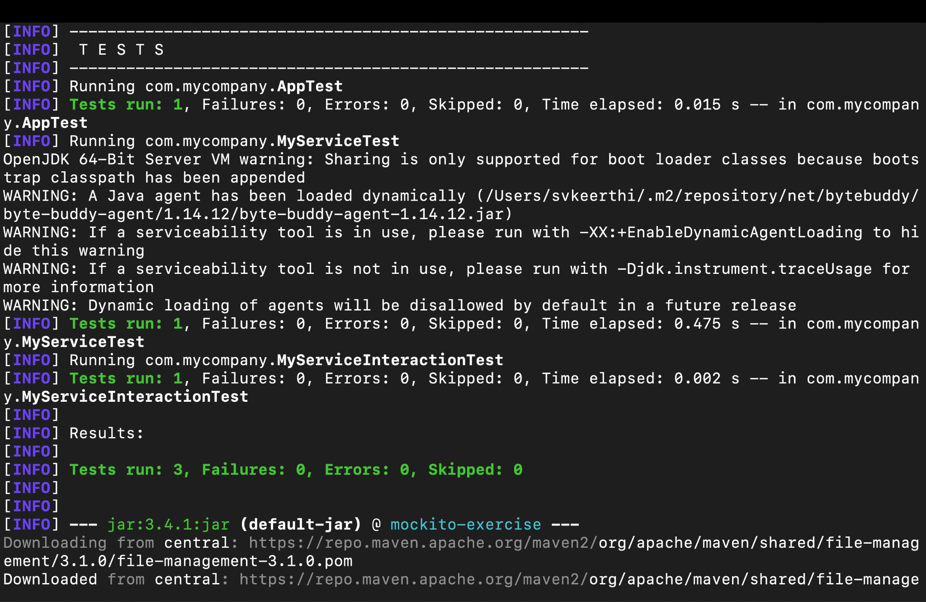
Output:
